DLD LAB 03 – IN LAB TASKS

Task 01 (a):

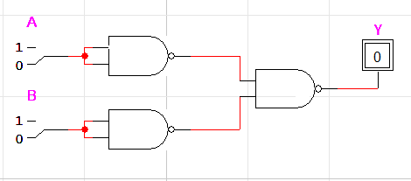

Task 01 (b):  
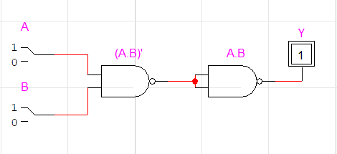

Task 01 (c):

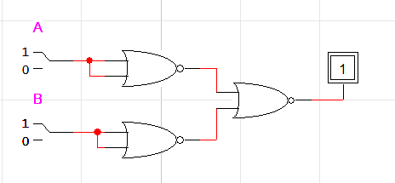

Task 02:

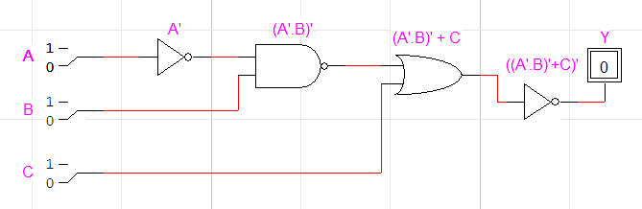

|  |  |  |  |  |  |  |
| --- | --- | --- | --- | --- | --- | --- |
| A | B | C | A’ | (A’.B)’ | (A’.B)’+C | Y |
| 0 | 0 | 0 | 1 | 1 | 1 | 0 |
| 0 | 0 | 1 | 1 | 1 | 1 | 0 |
| 0 | 1 | 0 | 1 | 0 | 0 | 1 |
| 0 | 1 | 1 | 1 | 0 | 1 | 0 |
| 1 | 0 | 0 | 0 | 1 | 1 | 0 |
| 1 | 0 | 1 | 0 | 1 | 1 | 0 |
| 1 | 1 | 0 | 0 | 1 | 1 | 0 |
| 1 | 1 | 1 | 0 | 1 | 1 | 0 |

Task 03:

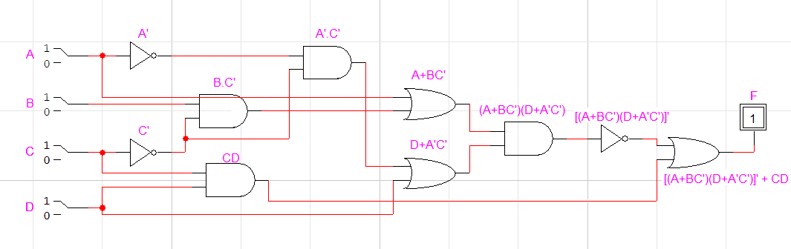

|  |  |  |  |  |  |  |  |  |  |  |  |  |  |
| --- | --- | --- | --- | --- | --- | --- | --- | --- | --- | --- | --- | --- | --- |
| A | B | C | D | A’ | C’ | BC’ | A’C’ | A+BC’ | D+A’C’ | (A+BC’)(D+A’C’) | [(A+BC’)(D+A’C’)]’ | CD | [(A+BC’)(D+A’C’)]’ +CD |
| 0 | 0 | 0 | 0 | 1 | 1 | 0 | 1 | 0 | 1 | 0 | 1 | 0 | 1 |
| 0 | 0 | 0 | 1 | 1 | 1 | 0 | 1 | 0 | 1 | 0 | 1 | 0 | 1 |
| 0 | 0 | 1 | 0 | 1 | 0 | 0 | 0 | 0 | 0 | 0 | 1 | 0 | 1 |
| 0 | 0 | 1 | 1 | 1 | 0 | 0 | 0 | 0 | 1 | 0 | 1 | 1 | 1 |
| 0 | 1 | 0 | 0 | 1 | 1 | 1 | 1 | 1 | 1 | 1 | 0 | 0 | 0 |
| 0 | 1 | 0 | 1 | 1 | 1 | 1 | 1 | 1 | 1 | 1 | 0 | 0 | 0 |
| 0 | 1 | 1 | 0 | 1 | 0 | 0 | 0 | 0 | 0 | 0 | 1 | 0 | 1 |
| 0 | 1 | 1 | 1 | 1 | 0 | 0 | 0 | 0 | 1 | 0 | 1 | 1 | 1 |
| 1 | 0 | 0 | 0 | 0 | 1 | 0 | 0 | 1 | 0 | 0 | 1 | 0 | 1 |
| 1 | 0 | 0 | 1 | 0 | 1 | 0 | 0 | 1 | 1 | 1 | 0 | 0 | 0 |
| 1 | 0 | 1 | 0 | 0 | 0 | 0 | 0 | 1 | 0 | 0 | 1 | 0 | 1 |
| 1 | 0 | 1 | 1 | 0 | 0 | 0 | 0 | 1 | 1 | 1 | 0 | 1 | 1 |
| 1 | 1 | 0 | 0 | 0 | 1 | 1 | 0 | 1 | 0 | 0 | 1 | 0 | 1 |
| 1 | 1 | 0 | 1 | 0 | 1 | 1 | 1 | 1 | 1 | 1 | 0 | 0 | 0 |
| 1 | 1 | 1 | 0 | 0 | 0 | 0 | 0 | 1 | 0 | 0 | 1 | 0 | 1 |
| 1 | 1 | 1 | 1 | 0 | 0 | 0 | 0 | 1 | 1 | 1 | 0 | 1 | 1 |